[Getting Started - GIT Installation](https://devcloud.swcoe.ge.com/devspace/display/~220038920/Getting+Started+-+GIT+Installation)

[Skip to end of metadata](https://devcloud.swcoe.ge.com/devspace/display/~220038920/Getting+Started+-+GIT+Installation#page-metadata-end)

* Created by [Sweatt, Corey Jarel](https://devcloud.swcoe.ge.com/devspace/display/~220038920), last modified on [Jul 05, 2016](https://devcloud.swcoe.ge.com/devspace/pages/diffpagesbyversion.action?pageId=1099711256&selectedPageVersions=3&selectedPageVersions=4)

[Go to start of metadata](https://devcloud.swcoe.ge.com/devspace/display/~220038920/Getting+Started+-+GIT+Installation#page-metadata-start)

**Installation**

1. Download and Install GIT at <http://git-scm.com/downloads>
2. Download and Install Sourcetree at <http://www.sourcetreeapp.com/>
3. Run the setup wizard, skip setup when asked for a BitBucket username/password. Do not use Mercurial.
4. Go to [https://github.appl.ge.com](https://github.appl.ge.com/) and Sign In. (Type your SSO and Password. The system will repopulate your information in 24 hours.)
5. Email your username to [Corey.Sweatt2@ge.com](mailto:Corey.Sweatt2@ge.com).
6. Open Sourcetree and Click Clone.
7. Insert one of the following into your Source Path / URL
   1. Technology Lab, repository for all Tech Lab Code (AP1,AP2,AP3)
      1. <https://github.appl.ge.com/220038920/techlab>
8. For Destination Path, you **MUST** use the folder locations below:
   1. Technology Lab:, "C:\Technology Lab"

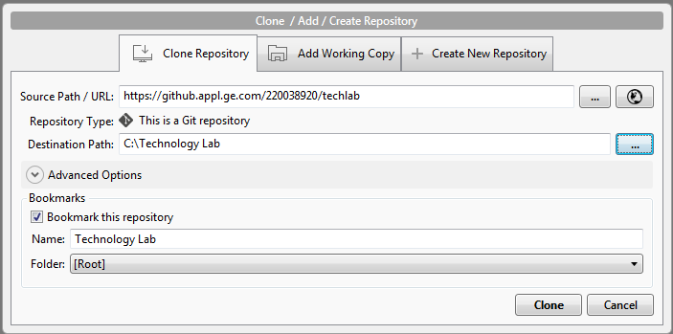

1. Click Clone.

**Help! My name no longer shows up next to my commits!**

If you're using SourceTree and you notice that your commits suddenly stop showing your name as the author then this section is for you. You'll need to edit your git config file, which exists for each and every repository you have cloned.

1. This file is located at \.git\config\ which is relative to your repository working directory.
2. For the Automation repository this should be located at C:\GitHome\Automation\.git\config
3. Open this file and add the following at the end of the file

[user]  
 name = Your name  
 email = YourEmail@ge.com

1. Repeat this for every repository config file.

**Working within the GIT Repositories**

** Before starting to work within a repository, ensure that you have talked with Paul Cason about initial GIT training **

Notes:

* **LabVIEW VIs are binary files.  Git is designed to easily merge Text-based programming languages.  Due to this, we must be very careful when multiple developers are working on the same code.  The basic rule of thumb is to communicate with your co-workers before working on the same elements of code.  Generally speaking, it is often best to breakup code into multiple subVI's such that each developer is never working on the same VI.**
* **Everyone should be using the C:\Technology Lab\* directories above.  If everyone uses these same directories, all SubVIs can be found with the same path and should work without LabVIEW having to search for them.**

**Common Code:**

All code heavily rely's on the common code and we must ensure that it is properly reviewed prior to pushing changes.  If you have changes to the common code or additions you would like to add, please contact corey.sweatt2@ge.com to setup a review.